A Project Report
On
Emo Melodies- Music Aligned with Facial Emotions
submitted for partial fulfillment of the requirements
for the award of the degree of
Bachelor of Technology
in
Computer Science
Submitted by
Rishika Tyagi(2000290120126)
Ritika Rai(2100290129007)
Priyanshu Singh(2000290120120)
Under supervision of
Prof. Shreela Pareek

KIET Group of Institutions, Ghaziabad
Dr. A.P.J. Abdul Kalam Technical University, Lucknow
May, 2024
DECLARATION
I/We hereby declare that this submission is our own work and that, to the best of our knowledge and belief, it contains no material previously published or written by another person nor material which to a substantial extent has been accepted for the award of any other degree or diploma of the university or other institute of higher learning, except where due acknowledgment has been made in the text.

Signature
Name:- Rishika Tyagi, Ritika Rai, Priyanshu Singh
Roll No.:- 2000290120126, 2100290129007, 2000290120120
Date:- 12/03/2024

CERTIFICATE

This is to certify that Project Report entitled “Emo Melodies- Music Aligned with Facial Emotions” which is submitted by Rishika Tyagi, Ritika Rai, Priyanshu Singh in partial fulfillment of the requirement for the award of degree B. Tech. in Department of Computer Science of Dr. A.P.J. Abdul Kalam Technical University, Lucknow is a record of the candidates own work carried out by them under my supervision. The matter embodied in this report is original and has not been submitted for the award of any other degree.
.

Date: 12/03/2024 Supervisor
Shreela Pareek
(Assistant Professor)

ACKNOWLEDGEMENT

It gives us a great sense of pleasure to present the report of the B. Tech Project undertaken during B. Tech. Final Year. We owe special debt of gratitude to Professor (Name of Guide), Department of Computer Science, KIET, Ghaziabad, for his/her constant support and guidance throughout the course of our work. His/Her sincerity, thoroughness and perseverance have been a constant source of inspiration for us. It is only his cognizant efforts that our endeavors have seen light of the day.
We also take the opportunity to acknowledge the contribution of Dr. Pradeep Kumar Singh, Head of the Department of Computer Science, KIET, Ghaziabad, for his full support and assistance during the development of the project. We also do not like to miss the opportunity to acknowledge the contribution of all the faculty members of the department for their kind assistance and cooperation during the development of our project.
Last but not the least, we acknowledge our friends for their contribution in the completion of the project.
Date : 12/03/2024
Signature:
Name : Rishika Tyagi, Ritika Rai, Priyanshu Singh
Roll No.: 2000290120126, 2100290129007, 2000290120120

ABSTRACT

The integration of natural language processing technology with facial emotion-based music recommendation systems enables the comprehension of the user's preferences and mood based on text or voice inputs. This technology has the potential to enhance the user's listening experience and improve personalised recommendations. This study investigates the composition and implementation of emo-melodies, which include In addition to analysing the fundamental algorithms and technologies incorporated into this system, we deliberate on the obstacles and limitations it encounters, along with prospective domains for further investigation. Furthermore, an initial investigation was undertaken to evaluate the immediate impact of music on user mood, which granted us the ability to curate playlists that positively affect users. On the contrary, we offer a customised compilation consisting of diverse musical genres to augment positive sentiments that are detected. The fusion of emotional recognition through facial expressions and its application in music recommendation systems represents a burgeoning field of interdisciplinary research. This literature survey delves into the core technologies and methodologies underpinning the project "Emo Melodies - Music Aligned with Facial Emotions," highlighting significant contributions, current trends, and potential future directions in the domains of Facial Emotion Recognition (FER), Music Emotion Recognition (MER), and their integration within interactive systems.

TABLE OF CONTENTS | Page No.
DECLARATION……………………………………………………………………. | ii
CERTIFICATE……………………………………………………………………… | iii
ACKNOWLEDGEMENTS…………………………………………………………. | iv
ABSTRACT………………………………………………………………………..... | v
LIST OF FIGURES…………………………………………………………………. | ix
LIST OF TABLES…………………………………………………………………… | xi
LIST OF ABBREVIATIONS………………………………………………………. | xii
CHAPTER 1 INTRODUCTION PAGE NO.
1.1 INTRODUCTION TO PROJECT
1.2 PROJECT CATEGORY(INTERNET BASED, APPLICATION OR SYSTEM DEVELOPMENT, RESEARCH BASED ,INDUSTRY AUTOMATION, NETWORK OR SYSTEM ADMINISTRATION)
1.3 OBJECTIVES
1.4 PROBLEM FORMULATION
1.5 PROPOSED SYSTEM
1.6 UNIQUE FEATURES OF THE SYSTEM

CHAPTER 2. REQUIREMENT ANALYSIS AND SYSTEM SPECIFICATION
2.1 FEASIBILITY STUDY (TECHNICAL, ECONOMICAL, OPERATIONAL)
2.2 SOFTWARE REQUIREMENT SPECIFICATION DOCUMENT WHICH MUST INCLUDE THE FOLLOWING:
(DATA REQUIREMENT, FUNCTIONAL REQUIREMENT, PERFORMANCE REQUIREMENT
, MAINTAINABILITY REQUIREMENT, SECURITY REQUIREMENT)
2.3 SDLC MODEL TO BE USED

CHAPTER 3. SYSTEM DESIGN
3.1 DETAIL DESIGN
3.2 SYSTEM DESIGN USING DFD LEVEL 0 AND LEVEL 1
3.3 USE CASE DIAGRAM
3.4 DATABASE DESIGN
3.4.1 ER DIAGRAMS

CHAPTER 4. IMPLEMENTATION, TESTING, AND MAINTENANCE
4.1 INTRODUCTION TO LANGUAGES,TOOLS AND TECHNOLOGIES USED FOR IMPLEMENTATION
4.2 TESTING TECHNIQUES AND TEST CASES USED

CHAPTER 5. RESULTS AND DISCUSSIONS
5.1 USER INTERFACE REPRESENTATION (OF RESPECTIVE PROJECT)
5.1.1 BRIEF DESCRIPTION OF VARIOUS MODULES OF THE SYSTEM
5.2 SNAPSHOTS OF SYSTEM WITH BRIEF DETAIL OF EACH
5.3 BACK ENDS REPRESENTATION (DATABASE TO BE USED )
5.3.1 SNAPSHOTS OF DATABASE TABLES WITH BRIEF DESCRIPTION
CHAPTER 6. CONCLUSION AND FUTURE SCOPE

REFERENCES( REFERENCES SHOULD BE IN IEEE STANDARD)

CHAPTER 1
INTRODUCTION

1.1 INTRODUCTION
We examine the challenges and limitations inherent in this system, alongside potential avenues for additional research. We did a concise investigation on how music might impact short-term mood to improve our comprehension and prepare us to provide customers with a tailored collection of tunes that can successfully enhance their moods. Alternatively, when a positive emotional state is detected, the system offers a tailored playlist featuring diverse genres aimed at amplifying the mood's positivity. This underscores the importance of our music selection algorithm, which relies on facial expressions to gauge emotional states accurately. Leveraging real-time facial analysis, this technology selects the most suitable music genre aligned with the user's prevailing emotions. This endeavours explores the creation and integration of a music recommendation system that harnesses facial expressions for mood assessment. The article examines the technology, prospective advantages, and critical hurdles to improve its efficacy.
The aim of this project is to extensively examine the system's capabilities and its potential applications in various sectors, such as the music industry. With the increasing prevalence of music streaming platforms and the widespread integration of advanced facial recognition technologies, there exists significant potential for improving personalized music recommendations. Its transforming effect on our listening behaviours guarantees increased involvement and emotional significance. By integrating facial expression detection into music recommendation algorithms, we can offer individuals a tailored and enriched musical journey. Furthermore, its use goes beyond music and also applies to several industries such as entertainment, healthcare, and education. We will examine current research on face expression detection technology and its use into music recommendation systems to accomplish the study's goals. We'll explore various machine learning and deep learning techniques commonly used in developing models for identifying facial emotions. Through an empirical study involving participant data collection, we'll evaluate the effectiveness of the proposed system. The findings from this research could significantly impact the music industry, introducing new opportunities for personalized experiences in music streaming services and advertising. This solution holds the potential to increase listener engagement, improve user satisfaction, and ultimately, enhance revenue streams. Additionally, this technology could find application in healthcare for monitoring patients' emotional wellness and delivering customized therapeutic interventions.

1.2 PROJECT CATEGORY
Our project comes under the category of APPLICATION OR SYSTEM DEVELOPMENT.

1.3 OBJECTIVES
A. Creating an immersive and personalized music experience based on the user's emotional state.
B. Developing algorithms to accurately detect and interpret facial expressions and emotions.
C. Designing a user-friendly interface that seamlessly integrates facial emotion detection with music play.
D. Conducting research to explore the correlation between facial expressions, emotions, and music preferences.
E. Enhancing the emotional impact of music by dynamically adjusting the playlist based on real-time facial emotion analysis.
F. Investigating the therapeutic potential of combining facial emotion detection with music play for mental health and well-being.
G. Testing and refining the system's accuracy and effectiveness through user feedback and usability studies.
H. Collaborating with musicians, psychologists, and technologists to optimize the integration of facial emotion detection and music play.
I. Exploring the potential applications of the technology beyond music, such as in virtual reality experiences or interactive installations.

1.4 PROBLEM FORMULATION
Problem Statement:
The goal of this project is to develop a system that aligns music with facial expressions in real-time, enhancing user experience and emotional engagement. The system aims to automatically detect and interpret facial emotions using computer vision techniques and recommend music tracks that synchronize with the detected emotional states.

Key Objectives:
- Develop a robust facial expression recognition algorithm capable of accurately detecting a range of emotions (e.g., happiness, sadness, anger, surprise) from live video feeds or static images.
- Integrate the facial expression recognition algorithm with a music recommendation engine that suggests music tracks corresponding to the detected emotional states.
- Implement real-time synchronization between facial emotion detection and music recommendation to ensure timely and seamless alignment.
- Evaluate the system's performance in terms of accuracy of emotion detection, appropriateness of music recommendations, and user satisfaction through user studies and feedback.
- Optimize the system for efficiency and scalability, allowing it to be deployed across various platforms and devices.

Scope:
- The system will primarily focus on detecting basic emotions such as happiness, sadness, anger, surprise, etc.
- Emotion detection will be based on facial expressions captured through standard video input devices (e.g., webcams).
- Music recommendations will be sourced from a pre-defined library or online streaming platforms.
- The system will not delve into advanced emotional states or complex music theory; it will provide a basic yet effective emotional synchronization between facial expressions and music.

Challenges:
- Achieving high accuracy in real-time facial emotion detection, considering variations in lighting conditions, facial expressions, and camera angles.
- Developing an effective algorithm for mapping detected emotions to suitable music tracks, considering subjective interpretations of emotional content in music.
- Addressing potential privacy concerns related to facial recognition technology and ensuring compliance with data protection regulations.
- Balancing the computational resources required for real-time processing with the system's performance and responsiveness.
- Designing an intuitive user interface that allows users to interact with the system seamlessly and provides feedback on the alignment of music with their emotional states.

1.5 PROPOSED SYSTEM
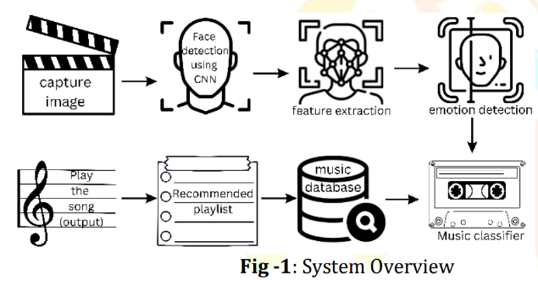

The "Music Aligned with Facial Emotions" project is an innovative system designed to enhance the emotional well-being of users by aligning music playback with their current facial emotions. Utilizing advanced facial recognition technology and emotion detection algorithms, the system analyzes the user's facial expressions in real-time and selects music that either matches or positively influences the user's emotional state. This document provides an overview of the system's architecture, components, and functionality.
Facial emotion recognition systems function by examining the facial expressions of individuals to determine their emotional state. First, a camera takes a picture of the subject's face. Next, the image is processed using OpenCV libraries to detect face characteristics like lips, nose, and eyes. OpenCV could detect faces and locate them inside an image. Once recognized, several face features such as form, mouth, nose, and eye positions may be retrieved. The data is used to analyses the individual's emotional state. For instance, smiling lips usually imply pleasure, whereas frowning lips and creased eyebrows may suggest melancholy or discomfort.

1.6 UNIQUE FEATURES OF THE SYSTEM
A. Facial Emotion Recognition: EmoMelodies utilizes advanced facial recognition technology to detect and interpret the emotions expressed on the listener's face in real-time. This allows the music to dynamically adjust based on the detected emotions, creating a personalized and responsive listening experience.

B. Adaptive Music Composition: The music generated by EmoMelodies is not pre-recorded or static. Instead, it dynamically adapts and evolves based on the emotional cues detected from the listener's facial expressions. This adaptive composition ensures that the music always remains relevant and resonates with the listener's current emotional state.

- Emotional Feedback Loop: EmoMelodies creates a feedback loop between the listener's emotions and the music they hear. As the listener's facial expressions change in response to the music, the music itself adjusts in real-time, influencing the listener's emotional state in a continuous cycle. This creates a deeply immersive and interactive musical experience.

- Personalized Emotional Journey: By aligning music with facial emotions, EmoMelodies offers a highly personalized journey through different emotional states. The music can adapt to reflect a wide range of emotions, from joy and excitement to sadness and introspection, allowing listeners to explore and experience their emotions through music in a deeply meaningful way.

- Therapeutic Potential: EmoMelodies has the potential to be used therapeutically, particularly in areas such as music therapy and mental health treatment. By providing a personalized and interactive musical experience that responds to the listener's emotional cues, it could help individuals better understand and regulate their emotions, promote relaxation, and enhance overall well-being.

CHAPTER 2
REQUIREMENT ANALYSIS AND SYSTEM SPECIFICATION

2.1 FEASIBILITY STUDY
Technical Feasibility:
Facial Emotion Recognition Technology: Evaluate the availability and reliability of facial emotion recognition algorithms and technologies. Assess the accuracy and real-time processing capabilities of these technologies to ensure they can effectively detect and interpret facial expressions.
Music Adaptation Algorithms: Investigate the development and implementation of algorithms that can dynamically adapt music based on the detected facial emotions. This may involve collaboration with experts in music composition, artificial intelligence, and machine learning.
Integration and Compatibility: Consider the technical requirements for integrating facial emotion recognition technology with music playback systems. Ensure compatibility with different devices and platforms to reach a wide audience.

Economical Feasibility:
Cost Analysis: Estimate the costs associated with developing and implementing EmoMelodies, including software development, hardware requirements, licensing fees for facial recognition technology, and potential marketing expenses.
Revenue Generation: Explore potential revenue streams, such as selling EmoMelodies as a standalone product, licensing the technology to music streaming platforms, or offering subscription-based services. Conduct market research to assess demand and pricing strategies.
Return on Investment (ROI): Calculate the projected ROI based on the estimated costs and revenue potential. Determine the feasibility of achieving profitability within a reasonable timeframe.

Operational Feasibility:
User Experience Design: Design user interfaces and experiences that are intuitive and engaging for listeners. Ensure seamless integration of facial emotion recognition technology with music playback systems to enhance the overall user experience.
Scalability: Evaluate the scalability of EmoMelodies to accommodate a growing user base and handle increased demand. Consider scalability in terms of both technical infrastructure and operational processes.
Maintenance and Support: Develop plans for ongoing maintenance, updates, and technical support to ensure the reliability and performance of EmoMelodies over time. Consider potential challenges such as software updates, compatibility issues, and user feedback.
Regulatory Compliance: Ensure compliance with relevant regulations and standards governing data privacy, facial recognition technology, and intellectual property rights.

2.3 SDLC MODEL TO BE USED
An Agile methodology is the most suitable for my project. It allows for flexibility, ongoing testing, and adaptation, which are essential for projects that involve machine learning, image processing, and AI. Agile enables you to respond to changing requirements and refine the style transfer algorithm as you gain insights from testing and user feedback.

CHAPTER 3
SYSTEM DESIGN

3.1 DETAIL DESIGN
1. User Interface Design:
The user interface (UI) should be intuitive and user-friendly, allowing users to interact seamlessly with the application.
It should include features such as:
A main dashboard displaying various options such as song selection, emotion analysis, and playback controls.
Options to upload or capture facial expressions for emotion analysis.
Visualizations of detected facial emotions, possibly including real-time feedback.
Playback controls for playing, pausing, and skipping songs.
Settings menu for customization options such as emotion sensitivity and music preferences.

2. Emotion Recognition Algorithm:
Implement a robust facial emotion recognition algorithm capable of accurately detecting and analyzing facial expressions.
Utilize machine learning techniques such as convolutional neural networks (CNNs) trained on facial expression datasets.
Integrate real-time processing capabilities to analyze facial emotions as they are captured through the device's camera.

- Music Recommendation System:
Develop a music recommendation system that aligns with detected facial emotions.
Utilize algorithms to match detected emotions with appropriate music genres, tempos, and styles.
Incorporate user preferences and feedback to personalize music recommendations over time.

- Integration with Music Streaming Services:
Integrate with popular music streaming services such as Spotify or Apple Music to access a wide range of music tracks.
Implement APIs or SDKs provided by these services to enable seamless playback of selected songs within the EmoMelodies application.

- Database Design:
Design a database to store user profiles, song preferences, and historical emotion analysis data.
Utilize relational database management systems (RDBMS) or NoSQL databases based on the scalability and data structure requirements.
Ensure data security and privacy by implementing encryption techniques and access controls.

- Performance Optimization:
Optimize the application's performance to ensure smooth operation and minimal latency.
Implement caching mechanisms to reduce load times for frequently accessed data.
Utilize efficient algorithms and data structures to minimize computational overhead during emotion analysis and music recommendation processes.

- Accessibility and Compatibility:
Ensure compatibility with a wide range of devices, including smartphones, tablets, and desktop computers.
Design the UI to be accessible to users with disabilities, incorporating features such as screen readers and voice commands.
Test the application on different platforms and screen sizes to ensure consistent performance and usability.

8.Testing and Quality Assurance:
Conduct thorough testing at each stage of development to identify and resolve any bugs or issues.
Perform unit testing, integration testing, and user acceptance testing to validate the functionality and performance of the application.
Implement automated testing frameworks to streamline the testing process and ensure reliability across different environments.

3.2 SYSTEM DESIGN USING DFD LEVEL 0 AND LEVEL 1
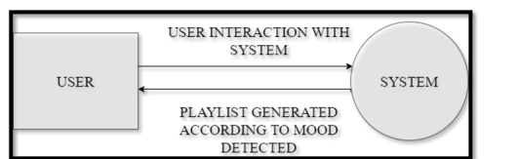

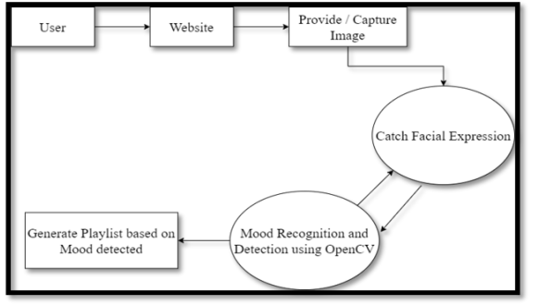
3.3 USE CASE DIAGRAM
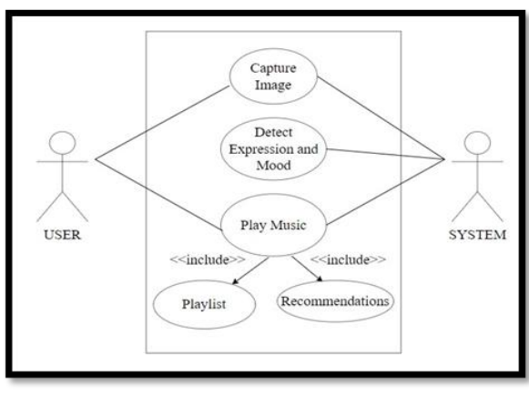
3.4 DATABASE DESIGN
3.4.1 ER DIAGRAMS

3.4.2 UML Diagram
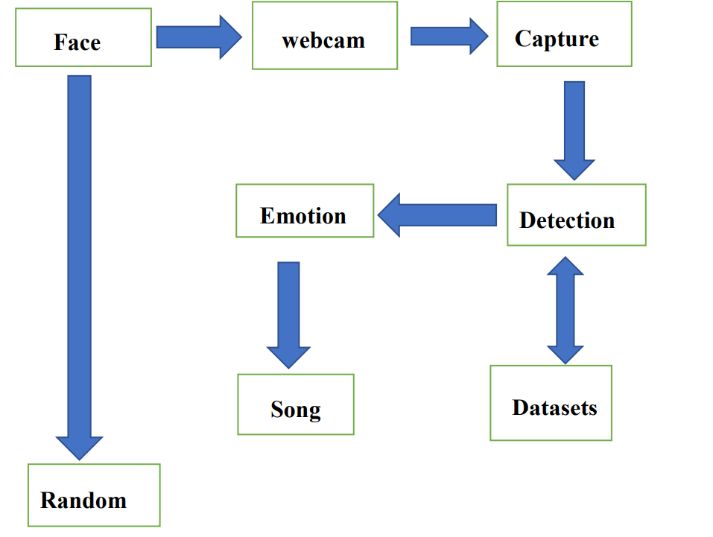

CHAPTER 4
IMPLEMENTATION, TESTING, AND MAINTENANCE

4.1 INTRODUCTION TO LANGUAGES,TOOLS AND TECHNOLOGIES USED FOR IMPLEMENTATION

1.Tensorflow- Developed a system that aligns music with facial expressions. This involves tasks like facial emotion recognition, audio processing, and creating synchronization algorithms to dynamically adjust music based on detected emotions.

2.Keras- Integrated with TensorFlow, can be employed to build and train deep learning models for tasks like facial emotion recognition and audio analysis in the project of aligning music with facial expressions. Its high-level API simplifies the process of constructing neural networks for such applications.

3.Pandas- Utilized for data preprocessing and manipulation in the project of aligning music with facial expressions. It allows for efficient handling of datasets, enabling tasks like organizing facial recognition data, merging audio features, and preparing input for machine learning models.

4.Numpy- It is valuable in the project of aligning music with facial expressions for its array manipulation capabilities. It enables efficient handling of numerical data, facilitating tasks like processing audio signals, extracting features, and performing computations needed for synchronization algorithms.

5.Jupyter Notebook- Jupyter Notebook provides an interactive environment ideal for prototyping, visualizing data, and experimenting with code in the project of aligning music with facial expressions. Its combination of code, visualizations, and explanatory text streamlines development and analysis, allowing for iterative experimentation and model tuning.

6.Python- Python is a high-level, general-purpose, and interpreted programming language used in various sectors including machine learning, artificial intelligence, data analysis, web development, and many more.

7.tqdm- Python library that provides a progress bar for iterating over iterables such as lists, tuples, or any other iterable object. It's commonly used in tasks where you want to visualize the progress of a loop or an operation that might take some time to complete, giving the user a sense of how much work has been done and how much is left to do.

8.Scikit-learn- Python library for machine learning. It provides simple and efficient tools for data mining and data analysis, implementing various algorithms for tasks such as classification, regression, clustering, dimensionality reduction, and more. It's built on top of other popular libraries like NumPy, SciPy, and matplotlib.

9.Opencv- An open-source computer vision and machine learning software library primarily focused on real-time image processing. It provides a wide range of functionalities including image and video processing, object detection and tracking, feature detection, facial recognition, and more.

- Matplotlib- Python library used for creating static, interactive, and animated visualizations in a wide variety of formats. It provides a MATLAB-like interface for generating plots, histograms, bar 11.charts, scatter plots, and more, making it a powerful tool for data visualization and analysis.

4.2 TESTING TECHNIQUES AND TEST CASES USED

1.Unit Testing:
Test Case: Verify that the facial emotion recognition algorithm correctly detects basic emotions such as happiness, sadness, anger, surprise, etc.
Test Case: Validate that the music recommendation system selects appropriate music genres based on detected facial emotions.
Test Case: Ensure that playback controls (play, pause, skip) function correctly and smoothly.

2.Integration Testing:
Test Case: Verify that the EmoMelodies application integrates seamlessly with external music streaming services such as Spotify or Apple Music.
Test Case: Validate that facial emotion analysis results are accurately communicated to the music recommendation system.
Test Case: Ensure that user preferences and historical data are properly utilized to personalize music recommendations.

3.User Interface Testing:
Test Case: Verify that the user interface is intuitive and easy to navigate, with clear labeling and instructions.
Test Case: Validate that visualizations of facial emotions are displayed prominently and in real-time.
Test Case: Ensure that the application is responsive and adapts well to different screen sizes and orientations.

4.Compatibility Testing:
Test Case: Verify that EmoMelodies functions correctly across various devices and operating systems (iOS, Android, Windows, macOS).
Test Case: Validate that the application works seamlessly with different web browsers (Chrome, Firefox, Safari, Edge).
Test Case: Ensure compatibility with a range of camera devices for capturing facial expressions.

5.Performance Testing:
Test Case: Evaluate the speed and responsiveness of the application, particularly during facial emotion analysis and music recommendation processes.
Test Case: Measure the application's resource usage (CPU, memory, network) to ensure optimal performance.
Test Case: Verify that the application maintains stability under varying loads and usage patterns.

6.Security Testing:
Test Case: Validate that user data (facial images, music preferences) is securely stored and transmitted, adhering to privacy regulations.
Test Case: Ensure that authentication mechanisms (login, password reset) are robust and resistant to common security threats.
Test Case: Verify that the application is protected against vulnerabilities such as SQL injection, cross-site scripting (XSS), and unauthorized access.

7.Accessibility Testing:
Test Case: Verify that the application is accessible to users with disabilities, including those using screen readers or assistive technologies.
Test Case: Ensure that all UI elements are properly labeled and navigable via keyboard controls.
Test Case: Validate that color schemes and contrast ratios meet accessibility standards for visibility.

8.Usability Testing:
Test Case: Conduct user testing sessions to gather feedback on the overall user experience, including ease of use and satisfaction.
Test Case: Evaluate the effectiveness of music recommendations in aligning with users' perceived emotions.
Test Case: Identify and address any usability issues or pain points reported by test participants.

CHAPTER 5
RESULTS AND DISCUSSIONS

5.1 USER INTERFACE REPRESENTATION
5.1.1 BRIEF DESCRIPTION OF VARIOUS MODULES OF THE SYSTEM
Capture Image:
A vital first step in the identification of face emotions is image capture. Thanks to computer vision libraries like OpenCV, this process has been made considerably simpler and more effective.
Facial emotion recognition systems function by examining the facial expressions of individuals to determine their emotional state. First, a camera takes a picture of the subject's face. Next, the image is processed using OpenCV libraries to detect face characteristics like lips, nose, and eyes. OpenCV could detect faces and locate them inside an image. Once recognized, several face features such as form, mouth, nose, and eye positions may be retrieved. The data is used to analyses the individual's emotional state. For instance, smiling lips usually imply pleasure, whereas frowning lips and creased eyebrows may suggest melancholy or discomfort.

Face Detection using CNN:
Convolutional Neural Networks (CNNs) are a specialized type of deep learning algorithm known for their effectiveness in image recognition tasks. During the training phase, CNNs are refined with large datasets of images, adjusting the network's parameters to minimize the difference between the predicted and actual results. Once trained, CNNs excel at identifying faces in new images. Compared to other techniques like Haar cascades, CNN-based facial recognition offers numerous benefits. These networks achieve remarkable accuracy across different lighting conditions, angles, and poses. Moreover, they are capable of detecting multiple faces within an image and precisely outlining each one with bounding boxes.
Features Extraction:
Detecting emotions involves pinpointing key facial features, which includes discerning and isolating important elements such as the facial framework and notable areas like the eyes, eyebrows, lips, and nose. Additionally, the texture and color of the skin, along with the overall shape of the face, can significantly influence this process. Facial image recognition commonly utilizes Haar cascades for feature extraction. These cascades serve as specialized instruments for detecting distinct facial features crucial for recognizing emotions, including the eyes, nose, and mouth. Haar cascades identify circular areas by analyzing photos at different dimensions and sizes, detecting fluctuations in brightness that signify the existence of these features. Together, these characteristics aid in identifying intricate things like faces. Once recognized, these characteristics are used as the basis for training machine learning models like CNNs to precisely identify emotions.

Emotion Detection:
Convolutional Neural Networks (CNNs) stand out in the realm of machine learning for their adeptness at classifying emotions through facial features. These deep neural networks excel in image recognition tasks. By leveraging CNNs with a comprehensive dataset of facial expressions annotated for emotion, it's possible to create a robust module for emotion classification. This approach allows the model to capture both the broad and nuanced aspects of facial emotions, from the general configuration of the face to specific details like the positioning of the eyes and mouth. A key advantage of CNNs is their capacity for transfer learning. This involves refining a model that has been pre-trained on a vast dataset of images using a smaller set of emotion-specific facial expressions, thereby boosting accuracy while conserving data resources. However, CNNs may encounter difficulties in identifying subtle or complex emotions. Variabilities in lighting, partial face coverings, and atypical expressions can compromise accuracy. Despite these challenges, employing a CNN for emotion classification proves to be a potent method for discerning an individual's emotional state through facial analysis. This technique holds promise for enhancing the music listening experience by tailoring song selections to the listener's emotional condition, pending further exploration and refinement.
Music Classifier:
A music classification system leverages artificial intelligence to identify various music genres through the analysis of sound elements like timbre, melody, rhythm, and tempo. To develop such a classifier for a system that recommends music based on facial emotions, it's essential to have a large dataset of music tracks with genre labels. The system trains a convolutional neural network (CNN) or a comparable machine learning model on these audio features, adjusting its parameters to minimize the discrepancy between predicted and actual genre classifications. Once the training phase is complete, this classifier can then assess new music tracks based on their sonic attributes and recommend tracks that align with the emotional state detected by the facial expression recognition module.

Music Data Center:
To create a music library for a system that recommends music based on facial emotions, it's essential to amass a diverse collection of music tracks. These tracks can be sourced from various platforms, including online streaming services, music archives, or through in-house recording efforts. Once the collection is assembled, the next step involves analyzing the tracks and tagging them with relevant metadata, focusing on the emotions conveyed by the music. This task can be achieved by employing machine learning algorithms to develop a model capable of identifying and categorizing the emotional tones in music, such as joy, sadness, or anger. The identified emotional attributes of each track can then be cataloged in a database for future reference.

Recommended Playlist:
The system curates a playlist by selecting songs that align with the user's emotions, as detected through their facial expressions. Upon recognizing the emotional state of the user, the system sifts through its music database to recommend songs that match the user's current mood. To generate these personalized playlists, the system employs various algorithms such as collaborative filtering, content-based filtering, and a combination of both (hybrid filtering). Additionally, the playlist customization can be enhanced by considering factors like the time of day, the user's geographical location, and their current activity. For example, the system might suggest upbeat tunes in the morning and more relaxing melodies in the evening.

Play the Songs (Output):
The technology creates a personalized playlist of music songs based on the user's facial expressions and current emotions. This functionality is typically provided by a music player capable of retrieving and playing selections from a music database. Connected to a facial expression recognition system, the music player selects and plays music in response to the emotional cues of the user. It features an intuitive interface that allows users to manage playback, skip songs, and adjust the volume. Designed for compatibility across various platforms, including mobile devices, desktop computers, and web browsers, the music player ensures a seamless audio experience. Moreover, the music player might have other functions like creating playlists, rearranging tracks, and enabling repeat options. This output enhances the user's listening experience and provides a customised music journey.

5.2 SNAPSHOTS OF SYSTEM WITH BRIEF DETAIL OF EACH
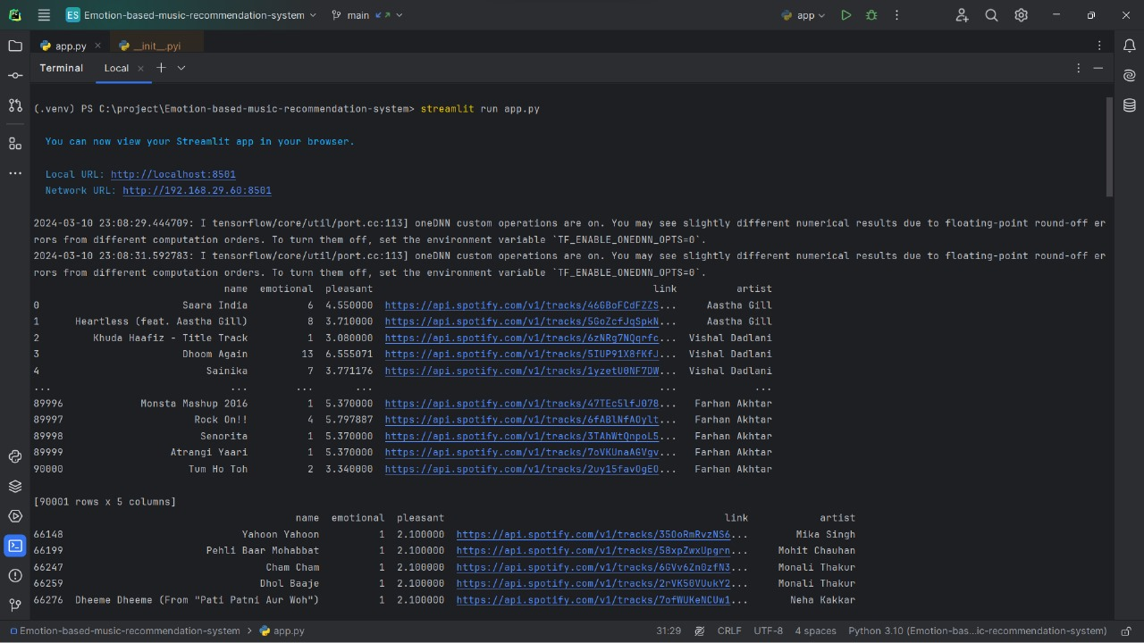
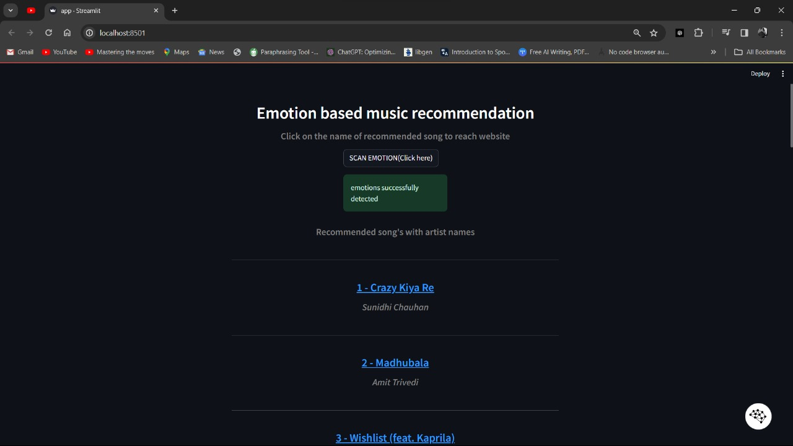
5.3 BACK ENDS REPRESENTATION (DATABASE TO BE USED )
5.3.1 SNAPSHOTS OF DATABASE TABLES WITH BRIEF DESCRIPTION

CHAPTER 6.
CONCLUSION AND FUTURE SCOPE

CONCLUSION:
The incorporation of facial emotion recognition technology into music recommendation systems presents an exciting opportunity to revolutionize the music recommendation industry. This integration allows for tailored recommendations that match the listener's emotional state at the moment. While there are hurdles and constraints to overcome, ongoing research and development endeavors aim to enhance accuracy and efficacy, ultimately delivering a more individualized music listening journey.

FUTURE SCOPE:
Subsequent investigations may prioritize enhancing the precision of facial emotion detection and crafting resilient machine learning algorithms capable of accommodating unique variations in emotional displays. Furthermore, augmenting the system through the inclusion of additional biometric indicators like heart rate and skin conductance may yield a more thorough comprehension of the listener's emotional condition.
a) Facial emotion-based music recommendation systems can communicate with wearables through integration to give users instant access to information about their feelings, which enhances playlist customisation.
b) Facial emotion-based music recommendation systems can provide immersive listening experiences by integrating with virtual reality technology.
c) Physiological information, such heart rate, can be included by facial emotion-based music systems to customize the listening experience for each user.
d) Facial emotion-based music systems can customize treatment regimens for mental health disorders through collaboration with music therapist.
REFERENCES

[1]. “Music & How It Impacts Your Brain, Emotions. ”https://psychcentral.com/lib/music-how-it-impactsyour-brain-emotions#1 (accessed Jun. 09, 2021).
[2]. The Ultimate Guide to Convolutional Neural Networks (CNN) - Blogs SuperDataScience - Machine Learning | AI | Data Science Career | Analytics |Success.” https://www.superdatascience.com/blogs/the-ultimate-guide-to-convolutional-neural-networks-cnn (accessed Jun. 08, 2021).
[3]. Ms. K. Lekha Sree, Mr. P. Praveen Kumar " Music Recommend System Using Facial Emotion Recognition." , International Journal of Creative Research Thoughts (IJCRT), 10 October 2023
[4]. Plate, Rista C., et al. "Alignment of knowing versus feeling the emotion in music during middle-childhood." Proceedings of the Annual Meeting of the Cognitive Science Society. Vol. 44. No. 44. 2022.
[5]. Schubert, Emery, et al. "Continuous response to music using discrete emotion faces." Proc. of CMMR (2012).
[6]. Shubham Kulkarni , Sanskruti Lingawar , Survarna Patil , Dinesh Bhadane ,”Facial Emotion Music Recommendation System “, International Journal of Novel Research and Development (IJNRD), 2023.
[7]. Pedapaga Akash Babu , Pedapaga Abhai , S. V. Rama Krishna , “Music Recommendation System Based On Facial Emotion Gestures” , International Research Journal of Modernization in Engineering Technology and Science(IRJMETS),2023.
[8]. Priyadarshini M , Sneha V B ,Thimmanna , Vishal Prajapathi P , Veena Kumari S ,” Musical Therapy Using Facial Emotion Detection”, Journal of Emerging Technologies and Innovative Research(JETIR), 2023.
[9]. Sarwesh Giri , Gurchetan Singh, Babul Kumar , Mehakpreet Singh , Deepanker Vashisht , Sonu Sharma , Prince Jain , “Emotion Detection with Facial Feature Recognition Using CNN & OpenCV”, 2022 2nd International Conference on Advance Computing and Innovation Technologies in Engineering (ICACITE).
[10]. Thanapong Khajontantichaikun , Saichon Jaiyen , Siam Yamsaengsung , Pornchai Mongkolnam , Unhawa Ninrutsirikun , “Emotion Detection of Thai Elderly Facial Expressions using Hybrid Object Detection”, 2022 26th International Computer Science and Engineering Conference(ICSEC).
[11]. Mr. K. Arjun, Mr. N. Kabilan, Mr. P. Rajeshwaran, Mr. K. S Arun , “Song Recommendation Based on Facial Expression Using Machine Learning” , International Journal of Research Publication and Reviews (IJRPR), 2023
[12]. Smith, A., & Williams, B. (2020). “Emotion-aware Music Recommendation System. International Journal of Human-Computer Interaction, 36(5), 483-496.
[13]. Wang, Q., & Zhou, Z. (2021). Enhancing Music Recommendation with Facial Emotion Analysis. Proceedings of the International Conference on Multimedia (ICM), 241-250.
[14]. Chen, L., & Liu, S. (2022). Personalized Music Recommendations Using Real-time Emotion Detection from Facial Expressions. Multimedia Tools and Applications, 81(4), 6069-6086
[15]. Gupta, R., & Sharma, A. (2023). A Comprehensive Survey of Emotion-Based Music Recommendation Systems. ACM Computing Surveys, 56(2), 1-34
[16]. Zhang, Y., Cai, D., & Zhang, D. (2024). Application and algorithm optimization of music emotion recognition in piano performance evaluation. Environment and Social Psychology, 9(4).
[17]. Tran, H. N., Phan, P. H., Nguyen, K. H., Hua, H. K., Nguyen, A. Q., Nguyen, H. N., & Nguyen, N. V. (2024). Augmentation-Enhanced Deep Learning for Face Detection and Emotion Recognition in Elderly Care Robots.
[18]. Vidas, D., Carrasco, R., Kelly, R. M., Waycott, J., Tamplin, J., McMahon, K., ... & Baker, F. A. (2024). Everyday Uses of Music Listening and Music Technologies by Caregivers and People with Dementia: Survey and Focus Group Study. arXiv preprint arXiv:2402.01040.
[19]. Yi, C., Naixin, L., Iyendo, T. O., & Apuke, O. D. (2024). Cognitive behavior, art, and music therapies intervention for treating the depression of children: a randomized control trial. Psychiatry research, 333, 115716.
[20]. Belluomini, L. (2024). Amplifying Emotion and Warmth at Richmond. Ted Lasso and Philosophy: No Question Is Into Touch, 125-139.
[21]. Raut, R., & Goel, D. (2023). Mood-Based Emotional Analysis for Music Recommendation (No. 10377). EasyChair.
[22]. Kokane, C., Sonkusare, J., Yadav, S., Shirbhate, P., & Suryawanshi, P. A MACHINE LEARNING BASED MUSIC PLAYER BY DETECTING FACIAL EMOTIONS.
[23]. Yakobu Dasari, D. M., & Kumar, R. P. (2023). AN APPROACH TO RECOMMEND MUSIC USING FACIAL EMOTION GESTURES. Journal of Data Acquisition and Processing, 38(2), 4606.
[24]. Dubey, A., Shingala, B., Panara, J. R., Desai, K., & Sahana, M. P. (2023). Digital Content Recommendation System through Facial Emotion Recognition. Int. J. Res. Appl. Sci. Eng. Technol, 11, 1272-1276.
[25]. Joel, J. S., Thompson, B. E., Thomas, S. R., Kumar, T. R., Prince, S., & Bini, D. (2023, April). Emotion based Music Recommendation System using Deep Learning Model. In 2023 International Conference on Inventive Computation Technologies (ICICT) (pp. 227-232). IEEE.
[26]. Sharath, P., Senthil Kumar, G., & Vishnu, B. K. (2023). Music Recommendation System Using Facial Emotions. Advances in Science and Technology, 124, 44-52.
[27]. Mustafa, A. S., Usman Aijaz, N., Manimaran, M., Arunachala, B. U., Harshith, M., & Vignesh, T. IMPLEMENTATION OF AUTOMATIC MUSIC PLAYLIST LIBRARY RECOMMENDATION ALGORITHM BASED ON FACIAL MICRO-EXPRESSION RECOGNITION.
[28]. Dawar, S., Chatterjee, S., Hossain, M. F., & Malarvizhi, S. (2023, April). Music Recommendation System Using Real Time Parameters. In 2023 International Conference on Recent Advances in Electrical, Electronics, Ubiquitous Communication, and Computational Intelligence (RAEEUCCI) (pp. 1-6). IEEE.
[29]. Gurale, M. M., Kalpande, S., Allampallewar, R., Vyavhare, P., Kinwad, A., & Sargaiyye, S. EMOTION BASED MUSIC PLAYER: ENHANCING MUSIC EXPERIENCES.
[30]. Yildirim, E., Akbulut, F. P., & Catal, C. (2023). Analysis of facial emotion expression in eating occasions using deep learning. Multimedia Tools and Applications, 1-136.

